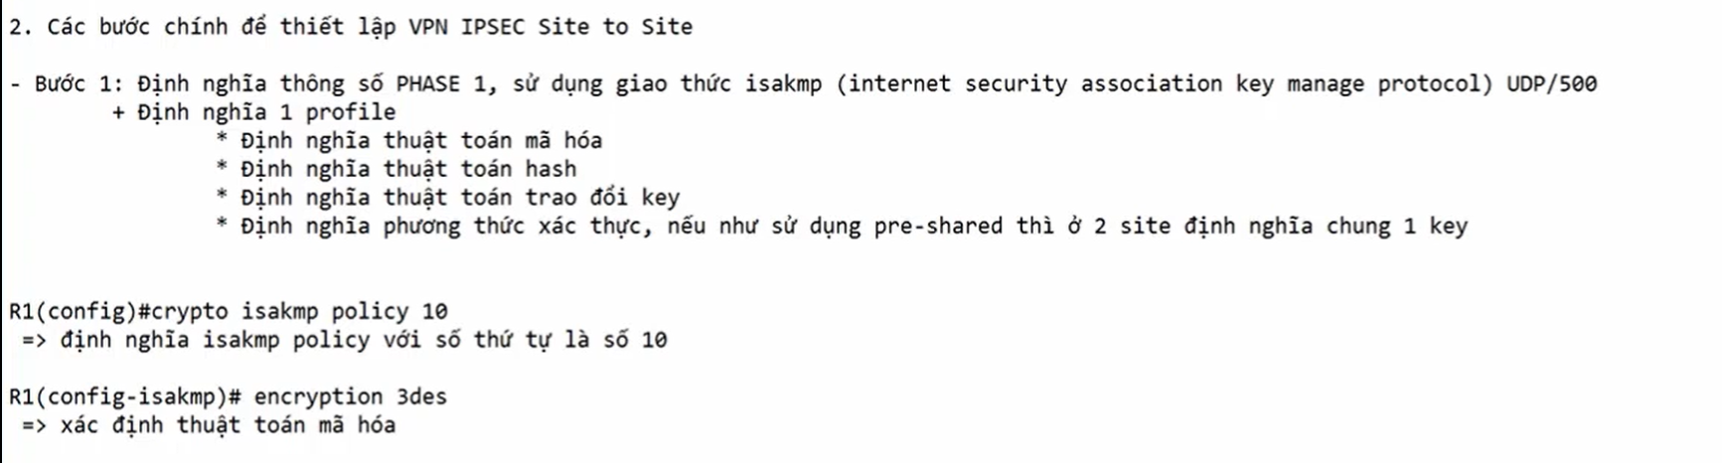

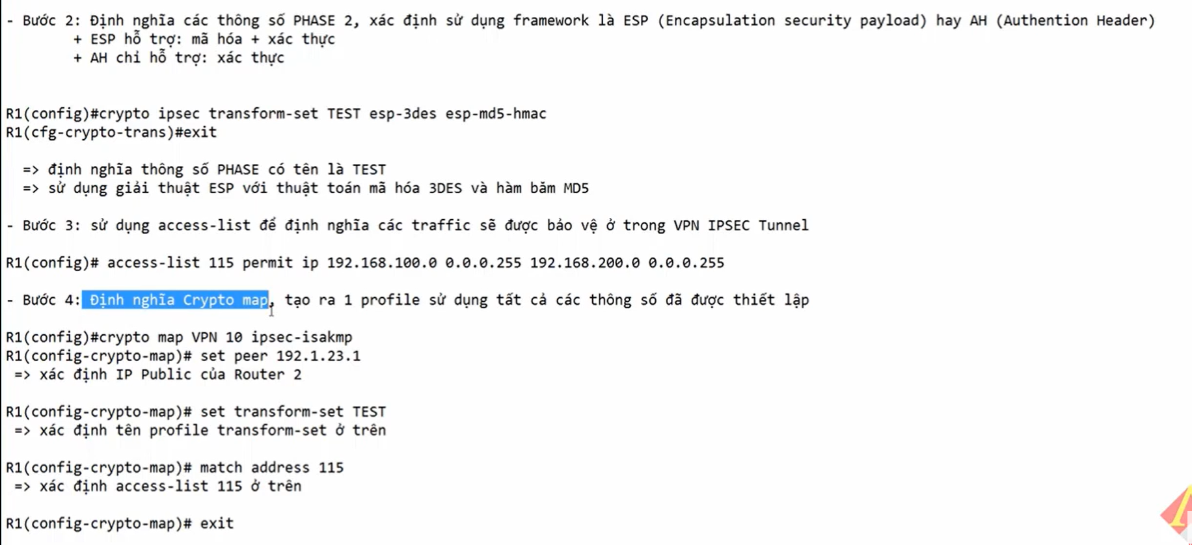

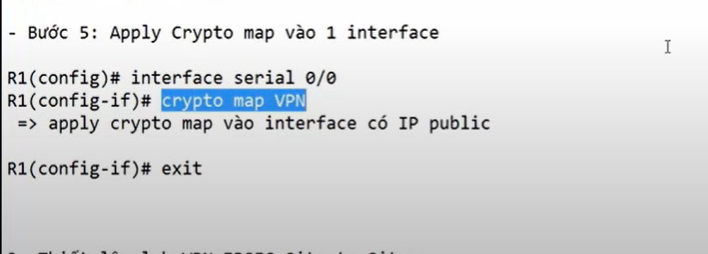

Thiết lập lab vpn ipsec site to site

1. Đầu tiên phải cấu hình để các route có thể ping đc cho nhau
2. **Cấu hình VPN IPSEC site to site tại L3**

Crypto isakmp policy 10

Encrypt 3des

Hash sha

Group 2

Authentication pre-share

Exit

Crypto isakmp key 6 cisco123 address 1.1.1.6

Crypto ipsec transform-set TEST esp-3des esp-md5-hmac

Exit

Access-list extend 115 permit ip 172.16.10.0 0.0.0.255 192.168.1.0 0.0.0.255

Crypto map VPN 10 ipsec-isakmp

Set peer 1.1.1.6

Match address 115

Set transform-set TEST

Exit

In e0/1

Crypto map VPN

Exit

**Cấu hình VPN IPSEC site to site tại R11**

Crypto isakmp policy 10

Encrypt 3des

Hash sha

Group 2

Authentication pre-share

Exit

Crypto isakmp key 6 cisco123 address 1.1.1.1

Crypto ipsec transform-set TEST esp-3des esp-md5-hmac

Exit

Access-list extend 115 permit ip 192.168.1.0 0.0.0.255 172.16.10.0 0.0.0.255

Crypto map VPN 10 ipsec-isakmp

Set peer 1.1.1.1

Match address 115

Set transform-set TEST

Exit

In e0/1

Crypto map VPN

Exit